# Project RoR Log

## April 24-30

### 

### 

### April 25

* Wrote Email to Helene about Help with project
* Created Elements Chart
  + [About Space Elements Chart](https://docs.google.com/document/d/13cC5NglG3xCTbQNuS5fa4w0gcDUtYLHTyTumMyMsY7Q/edit?usp=sharing)

### April 26

* Filled out contact form for Techstars

### April 27

* Created 1st wireframe-Wireframe for room
  + [Project RoR](https://docs.google.com/document/d/1poiCTQVj_NBMNJ6t0yHZgA0HQ_UU2mMYZdRqk8zGkiE/edit?usp=sharing)

ADDENDUM:

Getting started early was a good idea that set me up going forward. It would be nice for the techstars thing to work out. Talking to someone would be helpful.

The plan for the week going forward will be to design the layout for the website, figure out what elements will be needed.

### Weekly Log:

4/29 Received a response for Techstars, it was a generic letter with links to FAQs and no real way to connect with a person. But I looked over the FAQs and it seems to be mentorship for companies that are off and running and not just a project that is a glimmer in someone's eye. So basing a feasibility study off of what the Techstars would want for submission to the program is not really in the offing, so it will be a regular feasibility study, fine enough. I tried to cut and paste the email but that didn't work and Canvas seems to be a closed system to I can’t forward the email to a canvas address so here are some links to take a look at:

<https://www.techstars.com/faq?_hsmi=83673001&_hsenc=p2ANqtz--eFtwFjngcZjBKgbOI-VpwZ-KkP-SO1y-MkOu91i38y2JO1OIZ6jdi7rb99oQJcQrxSv5VAkw-e9knC7wXqwFBnvrfdQ>

<https://www.techstars.com/application-preview?_hsmi=83673001&_hsenc=p2ANqtz-9s33NvSNRD30YBlbjB6wwREavot9D1bnlSqWn1eeigh7gahajO0PNDjTBzlZfBqoBYeREIryELSRxwQolcsZqVGkcVvQ>

<https://www.techstars.com/accelerators>

4/30 I made a wireframe using an add-on to google docs. It is all messed up when it prints to google docs. I swear I saw a link to share it when I was making it but now I can’t seem to find a share link in the program I used to make the wireframe. Here is the google link:

[Project RoR Wireframe](https://docs.google.com/document/d/1poiCTQVj_NBMNJ6t0yHZgA0HQ_UU2mMYZdRqk8zGkiE/edit?usp=sharing)

I heard back from Helene She read my proposal and that is about it, we will see if she is willing to help.

## May 1-7

### May 1

May day. Pass the hot sauce, it’s a day for workers to rise up and eat the rich.

### May 2nd

A sketch of the website layout, could you call it a wireframe?

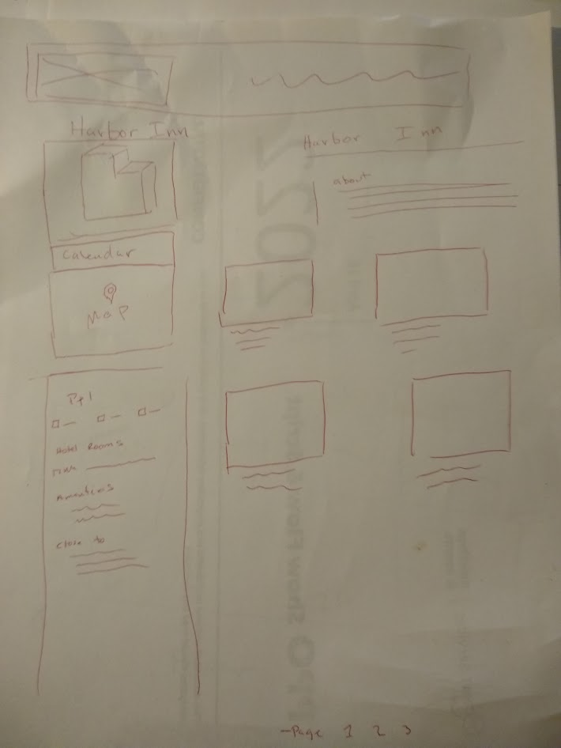

Yea, it’s a website shell. It’s so nice I think I will call it the Hebrides, cause, why not. I have never used one of those auto grid website makers, SO much easier than me doing it by hand, though I need the practice.



### May 3rd

It’s a database. Isn't she beautiful? I think I’ll name her Betsy. It took me 3 days to make this. I am not sure why?

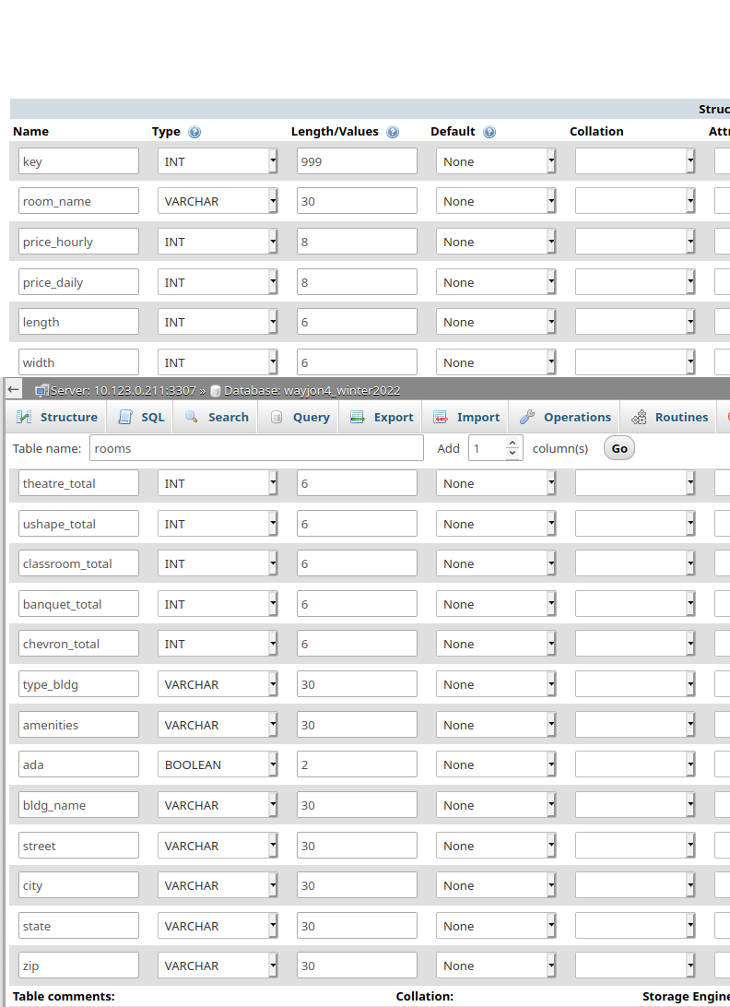

The list of event space websites:

<https://www.spacebase.com/en/>

<https://www.peerspace.com/plan/meeting>

All in all things went well enough. I was counting on doing some of this at work, but I took a new job and I may have to work while i am working. That could be a problem. By the time I get home and do a thing or two it’s 8pm and not much time to work ona project. We will see. Helen responded with a suggestion for a drop down menu which is cool but I was hoping for more, so it is sort of a bust. I’m sure she has her own work to do.

Next week I will try to get the database working.

## May 8-14

May 10/11

Had some time off from work and tried to get the database working. Had some progress. You can see the list of venues which are populated from the database. So that means that we are making it past the username and password for the database and the info is printing from the DB.

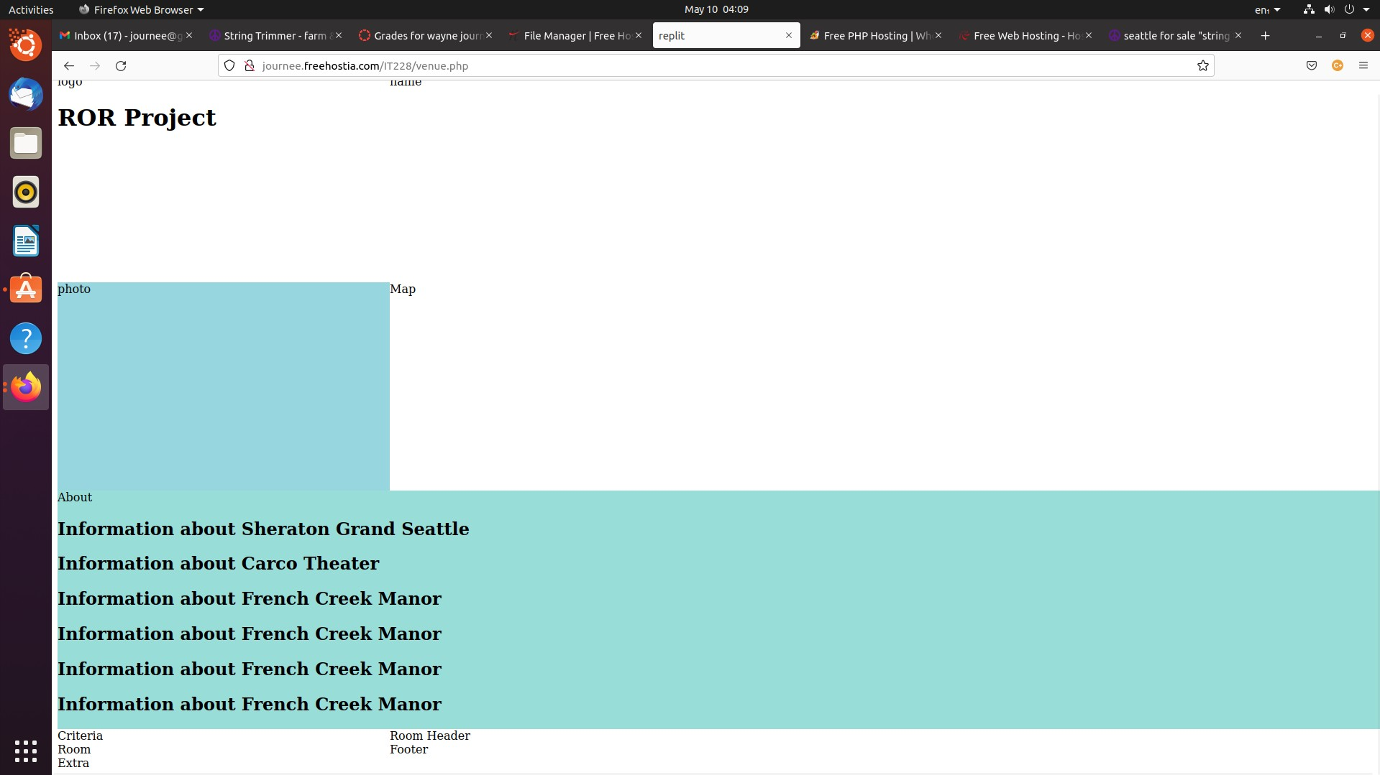

The problem is that the website host is not updating when I reload the code. The tutor told me about this last quarter but I only had the problem once and it took 10 minutes or so for the new code with changes to “show up” on the web hosting site. I made a change yesterday and it showed up today in the AM. Today I made some changes and six hours later it is still telling me that I have an error on line 31 and out of frustration I deleted line 31 so I can’t possibly have an error there but the same error pops up.

I am looking for a new hosting site.

May 14

Took a stab at making a Lucidchart:

<https://lucid.app/lucidchart/93e19d57-6f01-4380-8eca-78a7e65f36b2/edit?invitationId=inv_bc3c586c-dffa-4454-acac-4e1d44914d71>

The logic of my chart is that one venue could have many rooms but each venue could have only one address and type of building. Each room could only have one set of dimensions and one set of totals for the number of people who could fit in the room. Given this the chart has two columns and one key.

Looking for hosting site was not fruitful so I decided to make the webpage and I figured I would insert the PHP into the website so If things slowed to a crawl I would still be mostly done. I still have plenty to do but at least I am finding some time to work on it. You can see the website here:

<https://replit.com/join/keobhjljqd-1crabbyapple>

I have 61 hours of work next week. That is a lot of work leaving only time for sleep and a shower. I should be able to get some stuff done while working. It is a little hard to do some things since my attention is slightly split between homework and the paid work and it can be hard to keep my focus.

## May 15-21

May 19th

Yesterday I spaced on my user name and couldn’t open up the database so I started working on the feasibility study. It seems like it is going to be OK, it is not a crazy in depth analysis, which is beyond the scope of this project, but to my eye it is light on the BS. I have read some business plans and it seemed heavy on sunshine and unicorns. I sparked this idea 15 plus years ago. I thought it would be a good idea to start a company that supplied this information but did not understand how I could make it financially viable. I’m not convinced that it will be the next household product but I know there is a need for this information and after working through some of this I see a way to make it work financially, humm, this could be a thing.

Kate, the Seattle Central tutor, is at the 5th Ave theater right now. She has some tickets to the show for helping me get through my PHP class. Hope it's a good show.

My laptop is crapping out the spacebar only works half the time, it's a bummer.

Somehow I have to make it to the library in order to get information on the market size for meetings and conventions. And the true hard part is that I need financials. I need an accounting tutor to help if there is one thing I can't do, it's accounting.

May 20th

I need some stats on the conference/meeting market, whether it is growing or shrinking and its value. You can only get this information at the UW business school or the downtown library. This is a case of my tax dollars not working for me. I took a look at the website and the library was open so I headed downtown only to find out that the business desk is only open on Tuesdays and Wednesdays. So not cool.

May 21st

I hope to get the plan done and work on making the website this coming week. I am a bit stuck on getting the code to work. I have to jump that hurdle somehow.

## May 22-28

May 26th

I got the two pages working and they work with each other and they are talking to the database. While I have said this in the past it has been a one step forward then a step back sort of journey. I’m still having trouble with the server updating when I upload the new code it does not show. This is helpful for cleaning the house since when it does not work I get up and do something around the house, like clean, while I wait for the server to catch up. But it is not helpful for getting the project done. I took a look at using replitwhich I noticed has a database function but it uses the method for creating a database that I don’t remember so well. If I had a cheat sheet maybe I could do it that way.

May 28th

Wednesday I will try to make it to the library. I will also try to finish adding the elements to the webpage which will leave what turns out to be the hard part, lots of CSS and massaging the page into something that looks nice.

Here is a link to the financials:

<https://docs.google.com/spreadsheets/d/1ttVfs2Y2Tf0S3WWPdR2ktPieqdx4TYt3dNWEEXWtJz0/edit?usp=sharing>

I based things on a monthly amount, so some one time costs like a lawyer, who would help set up a corporation, divided it by 12 . This way all everything is monthly and not some yearly and some monthly charges. Maybe that was wrong but it seemed like the thing to do at the time. The amount seems kind of low for a start-up, you always hear about millions and billions pouring through tech start-ups and this is pretty tame so I am wondering if I am even close to what I should include. I poked around the net looking for line items and added all that made sense, so in theory it is legit.

May 29th to June 4th

May 31st.

Spent a fair amount of time working on the site. It is starting to look like a site and has functionality.

Link to the website:

<http://journee.freehostia.com/IT228%20Capstone/index.php>

June 1st

Went to the library, no joy. Last time I went to the business desk at the library there was a true librarian (most are just folks behind the counter and don’t have a library science degree) and she was the business librarian. Today, the librarian knew nothing about business databases and was no help, so I came away empty handed. Truly no joy.

June 4th

Yesterday, I had full functionality and I managed to get the CSS done, so things were more or less done as far as the website goes. A day that I was not sure would ever arrive, celebration and joy. The site was very plain Jane, simple CSS and a simple font. Since I was splitting my time between a database, a website, and a business plan I strove for function over form.

If you were paying attention you may have noticed the past tense, I got up this morning and the website was messed up. Since I was about as done as I was going to get and I had a little more time I thought I would add two more things. One was a list of other venues that are not in the venue of the room currently on display, or other rooms close by in other buildings. Second, I was going to add another database that features professionals that one may want to hire for an event. Think car service, caterer, DJ and the like. None of the current sites feature this therefore this would be a competitive advantage. The list of professionals is beyond the scope of the project, it is something that I discovered while writing the feasibility study, so if I don’t get to it it should be OK. Or it may take the place of the nearby sites section.

Alas, My efforts to add other things has, so far, only resulted in web page chaos. I’m sure it is a simple problem, a missing </div> tag most likely, either way it was not what I wanted to see.

The feasibility study is as done as it is going to get. I figured out what I wanted to know, which is if the idea is economically feasible. It is missing some content but if the library is closed or does not have real librarians what can I do? I don’t have time to make it to the UW and if you are not a business student they tend to have an attitude about letting one use their database. I don’t need their ‘tude.

I’m not sure how to turn this in officially but you can take a look at it here. I need to do some formatting and a few other things but you can take a look if you like:

[Feasability](https://docs.google.com/document/d/1EJwNj0-h5Kwam40BC2Gz-9yPOv0_4CXmY_vKpJ1_FYw/edit?usp=sharing)

So, on Monday and Tuesday I plan to :

* Make a database for professionals and add a website to display it.
* Add functionality for other nearby venues
* Edit the feasibility study one more time and format it